

CMPSC 462 (Spring 2025)

Data Structures

Movie Recommendations

Earl Hibbs, Jack Demtshuk, Nicholas Taweel, Ishaq Halimi

Instructor: Vinayak Elangovan

Submitted On: May 5th, 2025

**TABLE OF CONTENTS**

|  |  |  |
| --- | --- | --- |
| 1 | INTRODUCTION | 3 |
| 2 | BACKGROUND | 3 |
| 3 | DESIGN & IMPLEMENTATION | 4 |
| 4 | JUSTIFICATION FOR SELECTING DATA STRUCTURES | 12 |
| 5 | RESULTS / SAMPLE OUTPUTS | x |
| 6 | CONCLUSION | x |
| 7 | CONTRIBUTION | x |
| 8 | REFERENCES | x |

1. **INTRODUCTION**

For our project, we wanted to be able to implement a movie recommendation system. We want to be able to recommend to the user a movie, based off of the tags and genres that the user has specified that they like. When incorporating this recommendation system, we want to utilize the structure of a tree. We will have a user database that will have saved specifications, with a login feature and a watched movies feature. We also implemented further recommendations based off of the movies watched by the user. Additionally, we have a basic user deletion function as well to make sure the user database isn’t bloated, with some mild password protection using a python library.

1. **BACKGROUND**

The main purpose of this project was to demonstrate the structure of trees. The trees were the main source for recommending users based off the genres. We implemented a database online that contained 100,000 movies, using only 2,000 of those movies to make things feasible.

For trees, they are structured like a hierarchy, with a parent node at the top, followed by children nodes underneath the parent node, and it keeps going downwards. Essentially, I had the top node be the parent node, or just “Genre.” This was my root, just to specify what the tree was. Then, I branched the tree off into multiple subcategories.

Our graphs were utilized when incorporating the watched movie list. When the user gets recommendations, they can mark which movies are watched. Based off of what movies they watch, the graph connects them based off of how many tags are like each other. More similar tags, the higher the weight, the better the recommendation.

When traversing the tree, we ended up going in level order, because our recommendations were based off of how far down the genre was from the parent node.

1. **DESIGN & IMPLEMENTATION**

When designing and implementing our project, we had a finalized UML diagram that we were following and even expanded upon as we saw fit as we continued our project.

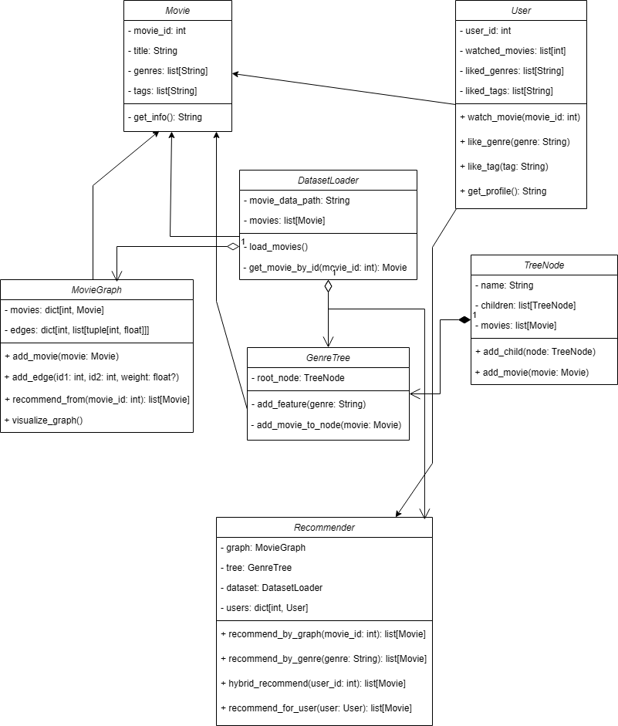

Although our initial UML diagram contained some graph-related functions, we shifted our idea with graphs to be utilized with the watched movies that the user specifies. When we implemented our dataset, we took the 2000 movies from our 100,000 movie database and made the whole thing into a graph. Each movie had tags, and each node was a movie. Any movie that had any corresponding tags that matched, we would mark as a neighbor. Each neighbor would have a weight of 1 for the 1 tag that was similar. Any additional tags that had similarities would be given extra weight to suggest the movie more. This is the build edges function, whose time complexity needed to be reduced in order to function with our huge dataset. It used to be **O(n2), but it would never run.** We have adjusted the algorithm, so the time complexity is lowered, to **O(m)**, having m being the number of movies we have, which is 2000. Here is the function:

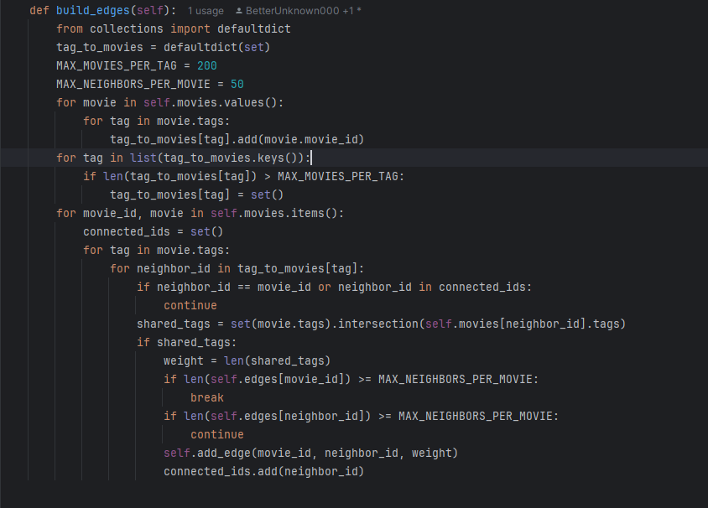

Our tree was hard coded, meaning that the structure of it was set in place. This is a diagram of the hard coded tree that we had.

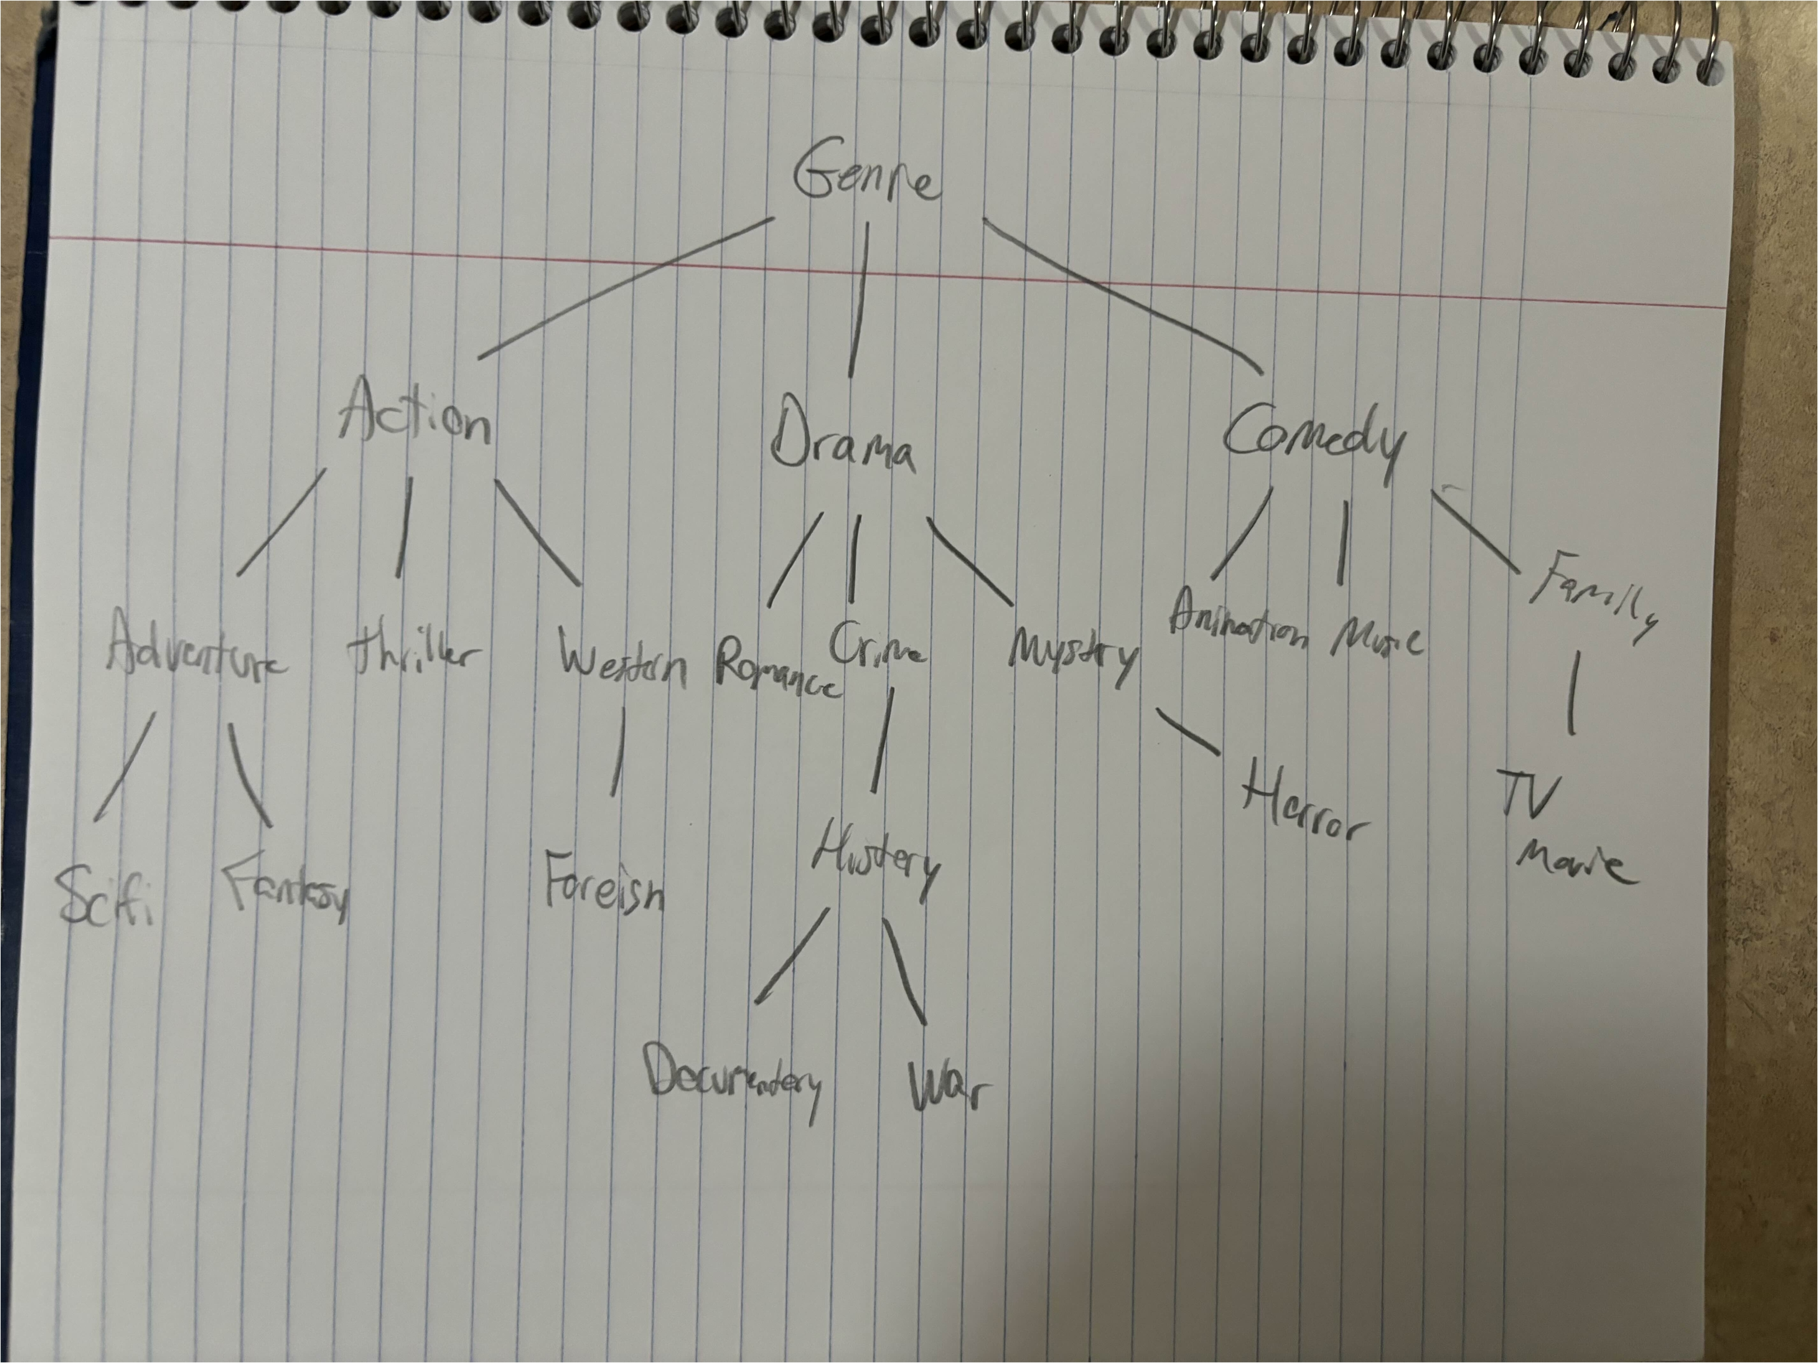

In our python-based system, we had a sample user database that we saved. The user database contained based information, with dynamically allocated IDs, username, password (which was encrypted since this user profile would be saved to a file).

When creating a user profile, the user would specify any liked genres or liked tags that they would have. This would be saved into the user profile and used in our recommendation algorithm. Additionally, there is also a watched user list. This list can be added and removed from the user profile page and will also give recommendations based from that movie that was watched.

Here is the structure of the user profile:

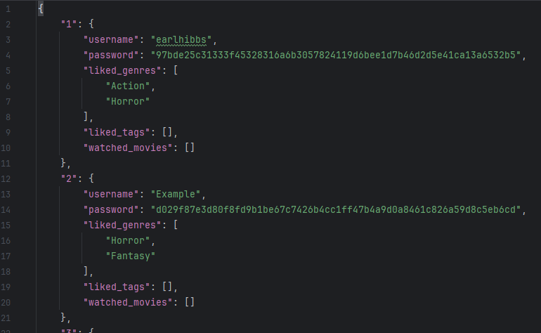

Once the user has created their profile, they would get recommendations based off of our recommendation algorithm.

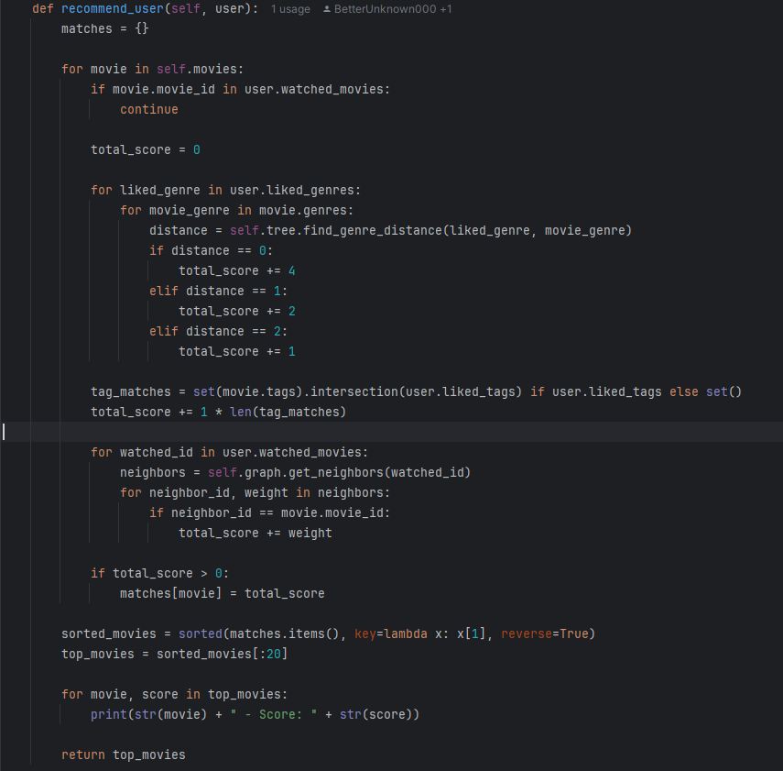

This is a very important function. The best-case time complexity is **O(n).** This is because there is a chance, although theoretical, that all movies are under the user’s “watched_movies.” Thus, you would skip through all the movies and the loops underneath, having only a time complexity of **O(n)**. Within this function, we use the tree to find the distance from the node (the liked genre to the movie genre) and recommend based off of how far it was on the tree. This is a level-order, or a DFS. Additionally, we used our graphs here to get our neighbors from the watched_movies.

We also have our dataset loader. This simply goes through our file, the cleaned_movies.csv, and writes it out so our code can read it. The time complexity of this function is simply **O(n)**, where n is our number of movies. Simply put, we go through our movies, and read it from file, once. We had a bunch of get functions inside this class, like get_movie_by_id() and get_movie_by_title(), which all resulted in **O(n)** time complexity, although less important in our program. Here’s what the code looked like: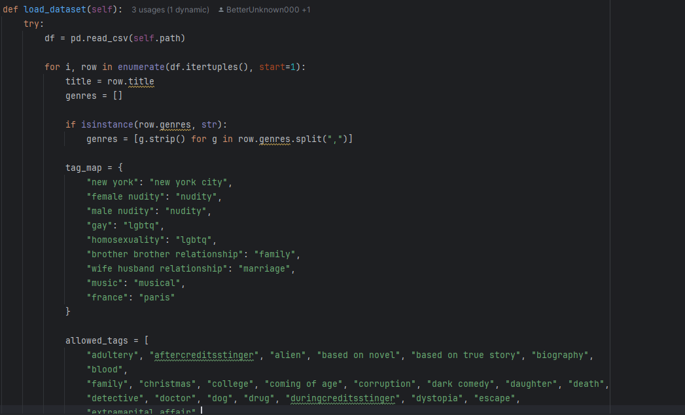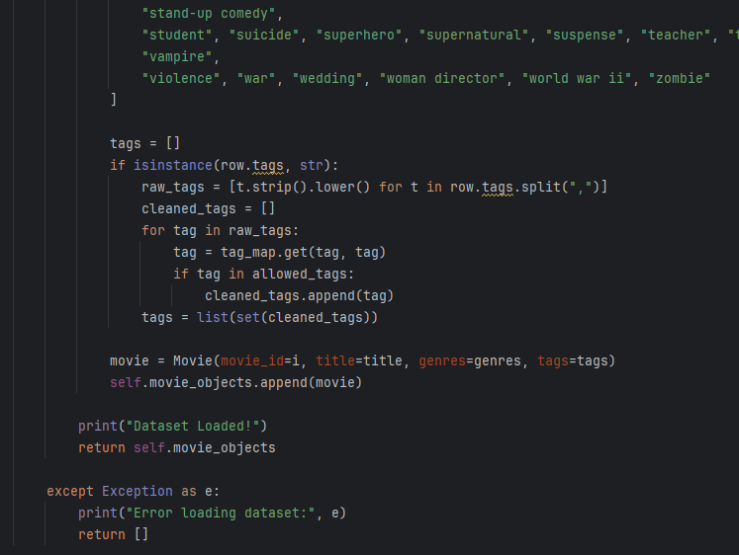

We also implemented a user database. There is a user manager python file that loads, saves, and adds users to a file. All these functions are **O(n)** time complexity where n is the number of users in our database, because each time you add, load, or save to the file, you are going to be going through the file from front to back. This is what the code looked like:

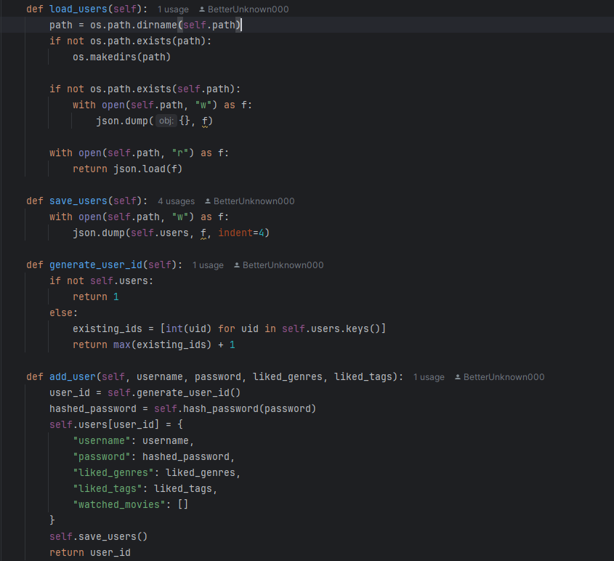

Lastly, we used a web-based server GUI named Streamlit. This was so we could properly upload our code to a website so that it can be easily accessed. Besides building the graph, which I have pasted above with its time complexity, nothing important was used in this file that requires time complexity analysis. Although an extensive file, all of it has been used for front-end GUI purposes.

1. **JUSTIFICATION FOR SELECTING DATA STRUCTURES**

**Tree:** We decided to utilize trees because of their hierarchical nature. When implementing our recommendation logic, we needed something to have a clear parent-child relationship for genres. Trees were the perfect data structure because of how they are organized, and the functions that you can perform on them. For our purposes, we used level order, or DFS. Basically, we go as deep as we can to find a connection, and the further we need to go to get from liked genre to movie genre, the less points that recommendation gets. Unlike lists or dictionaries, we need the tree to incorporate this “depth” logic that we need for our recommendations. Trees can easily utilize this whereas other data structures would require additional logic.

**Graph:** We utilized graphs because we needed the connections to judge how closely similar movies are based off the tags. Each movie will be a node, and similar tags will be added onto the connections of each node, with increased weight based off of how similar the tags are to each movie. We used these graphs to find “neighboring movies” on the watched movie list, which adds recommendation values based off what movies the user had watched. Instead of iterating through our dataset every single time we need to check a connection, which would cause huge time complexity issues, graphs saved the connections to require less checking. Using this graph with adjacency list also prevents high space complexity issues while still allowing neighbor lookups to be O(1).

1. **RESULTS / SAMPLE OUTPUTS**

Our project allows the user to create an account and select genres and tags that they like for films in our dataset to be recommended to the user based on their preferences. The main screen of the application prompts the user to either create a new account and select genres and tags they enjoy for recommendation, or to login to an existing account.

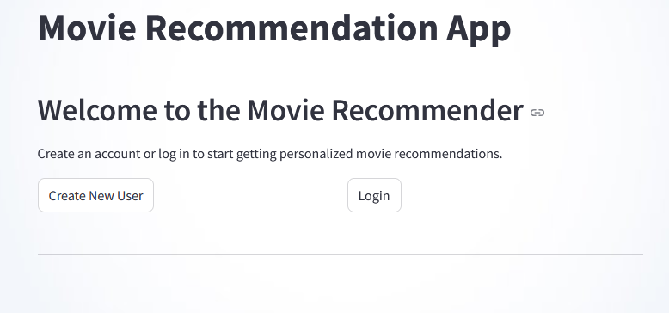

The user’s account includes a list of Top 20 movie recommendations that are given in a list based off of the user’s initial input of liked genres and tags. The user then can add or remove movies from their watched list, which will affect other films in the dataset and recalibrate recommendation points and the recommended list. Here is what an initial recommendation list can look like:

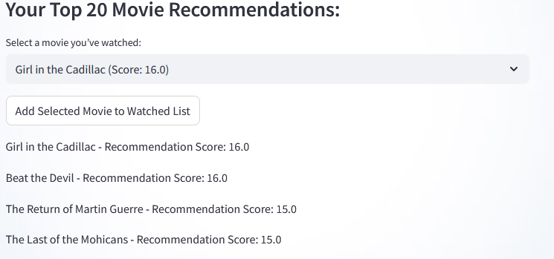When films are added to the watched list, their genres and tags can influence the recommendation points of remaining films in the dataset, while excluding watched films from being recommended to you. When ”Girl in the Cadillac” is added to the watched list, the list and the points of each film change.

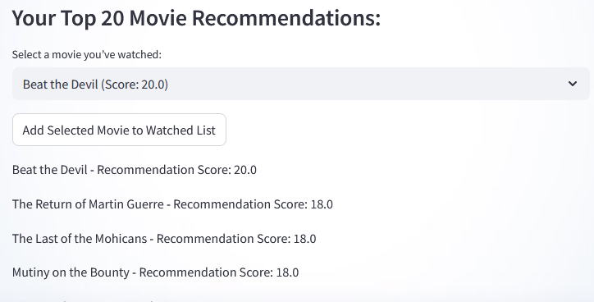Here, you can see that the second most recommended film, ”Beat the Devil”, had an initial recommendation score of 16, but after adding ”Girl in the Cadillac” to our watched list, it’s score increased to 20.

1. **CONCLUSION**

We all learned a lot when doing this project. For starters, we were challenged with the structures of trees and graphs. We were thrown into the deep end in a professional work environment, to help us get started with real coding projects. We solidified our knowledge with two important data structures, the **tree** and the **graph.** We were careful with time complexity, because our graph function wasn’t properly working with a **O(n2)** time complexity. We worked with a really large dataset this time and tackled the challenges with it. We were challenged with GitHub management and trying to figure out how that worked. We also worked on a project with a GUI for the very first time, and working around the preset methods and structuring that the GUI needs.

Overall, this was a great project that solidified our understanding and threw us into an advanced professional coding atmosphere, which tested how we can work together as a team, and helped us grow through our shortcomings and hopefully provide us with a project that we can share with future employers.

1. **CONTRIBUTION**

**Earl Hibbs –** I was the main leader of our group. I structured goals so that my team members could work in a timely fashion. I constructed the final UML diagram that everyone had to follow so that we could properly follow a unified code. I implemented the basic recommendation point system and algorithms needed to actually recommend the user. I structured the User model, UserManager model, Movie model, helped Jack structure the trees correctly, helped Nick fix up the graphs correctly because of time complexity issues, and a lot of the front-end main functionality.

**Nicholas Taweel –** I was designated work on the tag-related side of our project. We cycled through different structures, trying to find the best application of the tags. We tried graphs and trees but ultimately decided on using a dictionary system to group related tags together. Jack and I worked on implementing this. I had also worked with Earl on finding the best design for the Movie Graph and incorporating that into our recommendation system.

**Jack Demtshuk –** I oversaw handling the tree design and classes at first. I designed the structure of the genre tree, and created the tree class which is used to store and create the base data structure that the project uses to make recommendations. I created the tag cleaning program that replaced unnecessary and too specific tags from the base dataset with broader tags for better implementation. I worked on designing the Streamlit application, as well as helped with uploading and bug fixing related to the Streamlit. I also filmed the demonstration video.

**Ishaq Halimi** – I worked on collecting and preparing the initial dataset for the project. I compiled and cleaned the metadata, credits, and keywords files into a usable format that eventually became the foundation for our cleaned dataset. I created the original version of the DatasetLoader class to read this data and convert it into structured Movie objects using object-oriented programming. These objects made it easier to integrate with the team’s genre tree and tag-based graph systems. I also created the early version of the Streamlit interface app.py that allowed users to input a movie title and view its genres and tags. While these components were later improved and expanded on by the team, they served as a starting point for integrating data with the project’s underlying data structures.

1. **REFERENCES**

**Streamlit -** <https://streamlit.io/>

**Dataset –** Derived from MovieLens Dataset (<https://grouplens.org/datasets/movielens/>) and enriched with metadata.